**Fashion Image Tagging**

**Inspiration**

In this digital age, people are constantly seeking ways to simplify their lives leveraging technology. This is where closet apps come in.

There are 100s of closets apps available on major mobile and digital platforms, which offer you the promise of organizing your clothes for easy visibility, plan outfits for months on end, track clothing use to help calculate your cost/wear, and declutter your closet by identifying outfits rarely worn for easy disposal. An examination of the top 5 closet apps in the Apple App store offer the ability to mass upload pictures of clothing and deliver on the aforementioned features; however, there is a fundamental opportunity yet to be explored. In order to get the app ready, the user has to manually tag and classify each item and separate them into respective folders. What if we can use Machine Learning to automate this process and get the application ready for use in minutes versus hours? Wouldn’t this be a competitive advantage? Cue in Fashion-MNIST!

**The Data – Fashion-MNIST**

The opportunity to explore machine learning opportunities based on fashion classification has been one of great interest to the scientific community. For this reason, two prominent professors in the data science & analytics space leveraged the idea of the well-loved and vastly used handwritten digit dataset, MNIST, and developed their a new MNIST specifically for Fashion clothing identification.

*“Fashion-MNIST is a dataset of Zalando’s article images consisting of a training set of 60,000 examples and a test set of 10,000 examples. Each example is a 28×28 grayscale image, associated with a label from 10 classes. Fashion-MNIST is intended to serve as a direct drop-in replacement of the original MNIST dataset for benchmarking machine learning algorithms”*

*Source: Zalando Research URL:* [*https://research.zalando.com/welcome/mission/research-projects/fashion-mnist/*](https://research.zalando.com/welcome/mission/research-projects/fashion-mnist/)

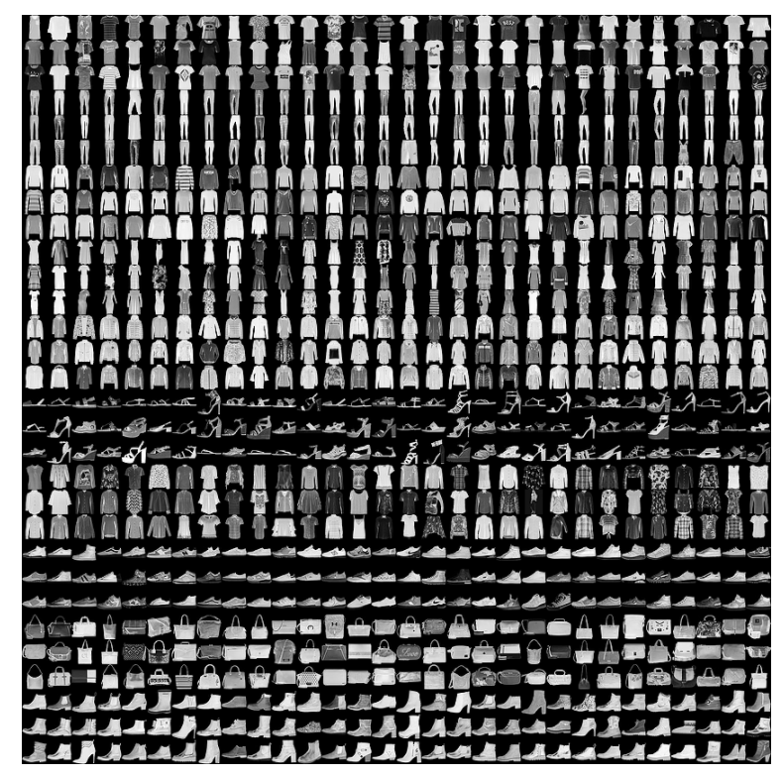

Fashion-MNIST was used to test and train our model but we wanted to use our model in a real-world application. Therefore, for our predictions, we randomly selected 50 images from various online clothing stores.

*Prediction images gallery*